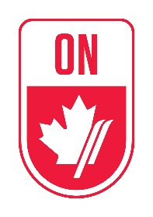
Alpine Ontario 2017 U16 Development Program Selection Criteria
The program will host up to a maximum of 30 athletes. The final selection number will be based on the number of athletes who meet the selection criteria. The final selected athletes will receive notification on Monday April 24th. The opening weekend for the program is May 6th & 7th at the Pan Am Centre in Toronto.

All applications are to be made to Alpine Ontario’s Athletic Director. Each application will require the following information for the application to be accepted:
- Letter of recommendation from Club Head Coach and/or age group coach
- Letter from the athlete outlining why they would like to be considered for the program and ski career objectives
- Resume from applying athlete. Including the following:
  - Academic standing
  - Fitness result
  - 2016/2017 review of season and points collected

The selection committee (AOA Athletic Director, AOA Executive Director, AOA Technical Consultant, and Divisional Athletic Committee member) will perform the following duties:
- Contact the Club Head Coach and discuss the application qualities based on the athletic character assessment document
- Interview the applicant either in person or via skype (parental supervision)

The selection criteria will be based on the following four elements:
- Academic standing (students must be in good standing and have a plan moving forward to continue this trend)
- Up-to-date fitness testing data and current engagement in a fitness program
- Score of 60 points or higher on the athletic character assessment, completed by the author of the Letter of Recommendation
- Interview, including ability to communicate effectively their desire to be accepted and complete the 11-month program
  - Exhibited a desire to complete in the high-performance level of the sport

